USN: 4AL17CS012 DATE: 03/09/2020

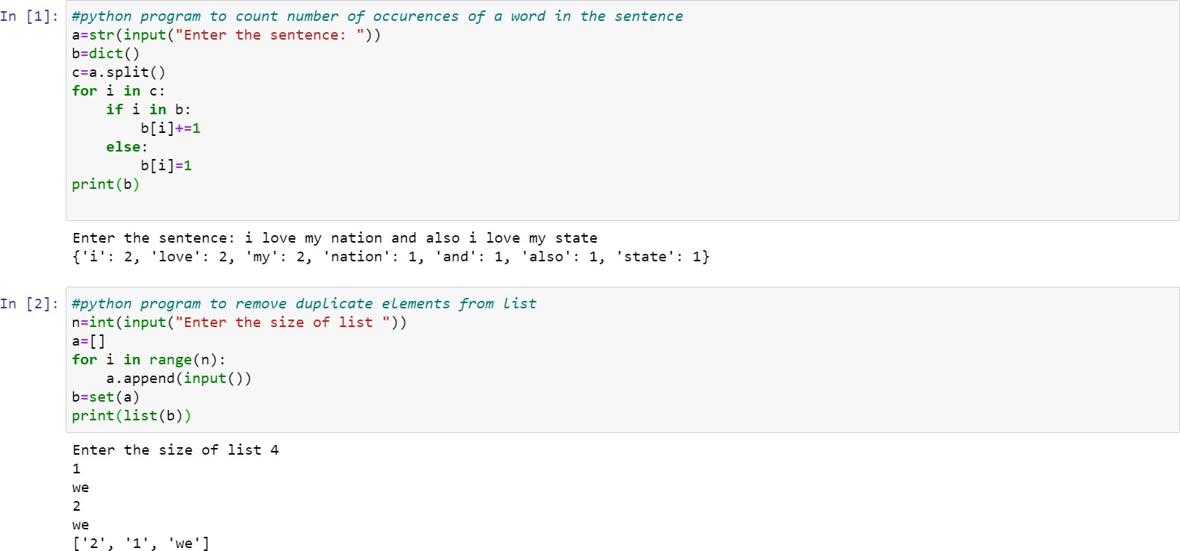

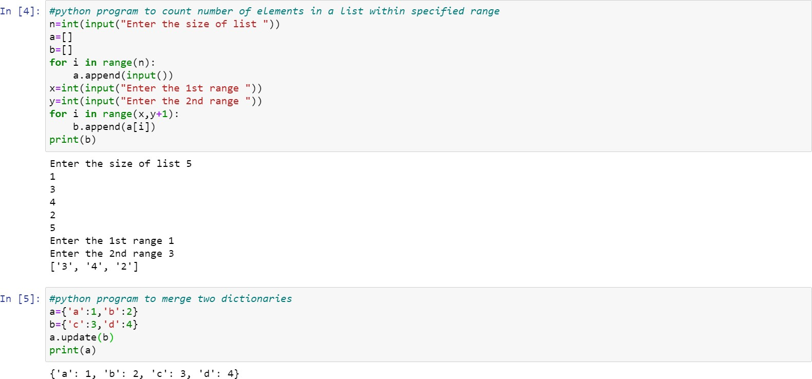

In [6] : *#python program* to /Tnd *highest 3* values tn *dtct\onary*

fron heapq 1aport nlargest

a=('a' : 7889, 'b' :5332, 'c' : 8645, ' d' : 6778, 'e' : 5789)

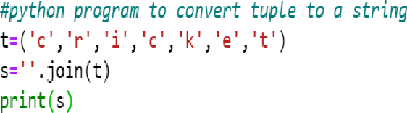b=nIargest(3,a, key=a.get) print (b)

In [7] :



In [B] : *#python program* to reverse *a tupLe*

t=('c', ' r' , ' i' , 'c','k', 'e', 't' )

list=1ist(t)

list. reverse( )

print (tuple(list))

Ir 18]:

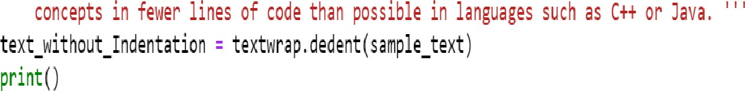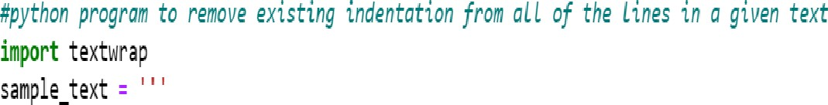Pyttoc is a widely used high-level, gectral-pcrpost, inttrpreted,dynaoic prograzoing language. Its design ptilosotty ecpâasi:

print(ttxt_zitâoct_Icdeitation )

print()

Python is a videly used tigt-level, general -purpose, interpreted, dynamic prograucing largoage. Its design tilosoptj euptasiies

# colt realatility, iri its syntax illozs Pro Warners to express

C0I1Ct§t S i0 ftktF IirleS 0f C0dt t#Zfl §0SSiglt iI1 fâ0g0tgtS SUCH âS C++ 0l^ 1âYâ.